BIOGRAPHY

Pastor Michael Gantz
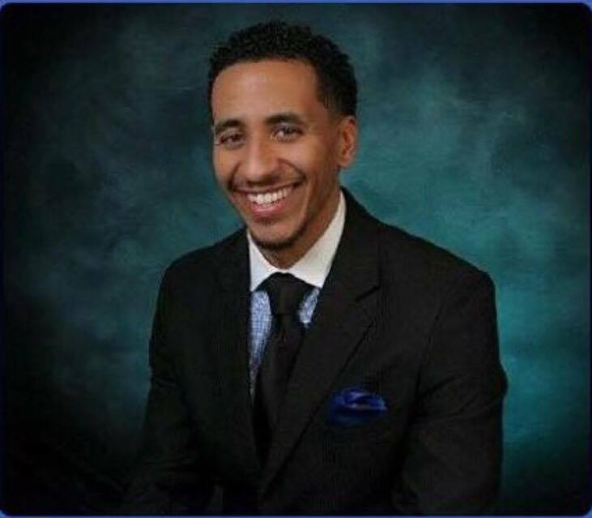
Pastor Gantz was born in Alliance, Ohio. He served two years in the Air Force in 2001 in Great Fall, MT. where he met his wife Ramona Gantz.

He accepted Christ in 2003 and accepted the call to ministry in 2004. Pastor and Lady Gantz have 3 beautiful children, Aliyah, Michael Jr., and Saniyah. He is an ordained Elder, and has attended the Bishop C.H. Mason Bible College and is currently continuing his seminary education. Pastor Gantz also serves as Chaplain of the Jurisdictional AIMS Sunday School and President of the Jurisdictional YPWW “Young People’s Willing Workers”. After arriving in Las Vegas in 2006, Pastor Gantz served under the guidance of Pastor John H. Langford of Tree of Life C.O.G.I.C. There he served as a minister and head of the Outreach Ministry.

Pastor Michael and Lady Ramona Gantz founded Kingdom Life Ministries C.O.G.I.C with 6 members on April 25, 2010 in Las Vegas, Nevada. The ministry has now grown to over 100 members and is still growing. Pastor Gantz, a sincere and upright man-of-God, has the utmost respect for the Brotherhood of God in Christ and a passion for the well-being of God’s people. His vision has lead him to establish a ministry focused on welcoming people from all walks of life to live the Kingdom Life creed, “It’s not just church on Sunday, it’s a lifestyle”. The ministry is fastened around Romans 14:17, “For the kingdom of God is not meat and drink; but righteousness, and peace and joy in the Holy Ghost”. His passion resides on outreach within the community and abroad, providing ministry and life’s basic needs to the lost.

