BIOGRAPHY

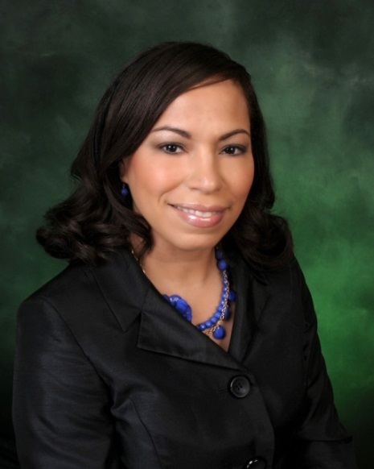
LADY RAMONA M. GANTZ

Lady Ramona M. Gantz was born in Oberlin Ohio in 1976 and enlisted in the United States Air Force in 1994 where she served for 20 years with extended tours to Afghanistan, Pakistan and United Arab of Emirates (UAE).

Lady Gantz met her husband, Michael L. Gantz in 2002. She accepted Christ in 2003 and began serving and seeking God. The two fell in love with God together and married in 2004.

Since arriving in Las Vegas in 2006, Pastor and First Lady Gantz served under the leadership of Pastor John H. Langford and District Missionary Josephine Langford. There, Lady Gantz began teaching Sunday school. In 2007, while still serving active duty in the Air Force, she earned an Associate’s Degree in Fitness & Recreation Management and a Bachelor’s of Science degree in Hospitality Management.

Pastor and First Lady Gantz opened the doors of Kingdom Life on April 25th, 2010 with only 6 members. Their vision has lead them to start a ministry welcoming people from all walks of life to live the Kingdom Life which is described in Romans 14:17, “For the kingdom of God is not meat and drink; but righteousness, and peace and joy in the Holy Ghost”. Their passion resides in a focus on outreach within the community and abroad, providing ministry and life’s basic needs to the lost.
Lady Gantz enjoys serving the Lord as Head of the Kingdom Life Women’s Department, Jurisdictional Executive Board member, Young Women of Excellence staff member and wherever she is called in the ministry. Lady Gantz has a heart and love for women and enjoys ministering to and pouring into women from all walks of life, introducing them to God and the love that he has for them. One of her primary goals is to help women enjoy a life changing and life-long relationship with God.
She has recently retired after serving 20 years of active duty for the U.S. Air Force. She now spends the majority of her time serving the ministry and mothering their three small children, Aliyah, Michael and Saniyah. In addition, they are business owners and founders of LV Groceries Delivered Fresh.com in which they serve the community, delivering groceries to customers throughout Las Vegas.

